Organist at St Mary’s Platt Church
Long Mill Lane, St Mary’s Platt TN15 8NE
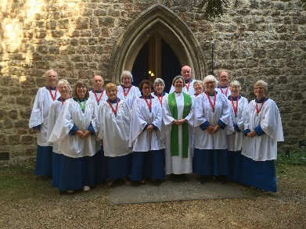
Full-time post involving playing for Sunday services, weddings and funeral/memorial services, when required, and for choir practice on a Friday evening.
In conjunction with the Vicar, the choir director chooses the music for services. She leads the 4-part robed choir of about 20 members.
The organ, dating from 1878 and one of the finest village church pipe organs in Kent, has recently been refurbished and includes a Trompette en Chamade.
St Mary the Virgin Platt is a very active church in which community engagement, music and children’s work are all important elements. We are seeking to continue to develop our ministry and mission through music and are open to the successful applicant(s) bringing new ideas as well as supporting our current pattern.
Remuneration in line with RSCM rates depending on qualifications and experience. Appointments will be subject to an enhanced DBS check. For further information and an application form, please email platt.church@hotmail.com
Closing date: 18th September 2026

